**4.Assumptions and limitations**

**Limitations:**

* The data used for analysis is limited i.e. limited patients under observation.
* The measuring equipment have limitations on measuring the values.
* Access to patients records have limitations and only the data related to project is available therefore we cannot access to other information. Limited access to the patient's medical history, therefore we can’t use any other information.
* Project team members are limited to work on the data as available in the file .

**Assumptions:**

* The measurements detected by the equipment’s are properly measured.
* The doctor’s diagnosis is assumed to be correct.
* All the testing equipment’s are in the best working conditions.
* Testing machines are properly calibrated as per prescribed guidelines.
* All the standards and SOP’s are followed during testing of patients.
* All the designated staff are properly trained for utilizing the testing equipment at its best working condition.

**Histograms is a visual display of a frequency distribution, histograms used for analysing all attributes of patients will provide the visual impression of the shape of each attribute and distribution of the measurements and information about the central tendency and scatter in the data.**

1. **Histogram of attribute MDVP :Fo(Hz)**

**Shape:** The distribution of MDVP:Fo(Hz) is unimodal it has one mode at a value of 120 about which the observations are concentrated.

The histogram is right skewed the larger values at right tail is much longer than the left tail.

**Outliers:** No outliers exist.

**Centre:** The centre of distribution approximately at 165.

**Spread:** The data of this attribute range from 85 to 255.

The test of MDVP Fo data is mostly distributed at 120 with a frequency of 49 and the 2nd is about 150 with a frequency of 30 the smallest frequency is at 255 the values at 135 and 165 have almost same frequency.

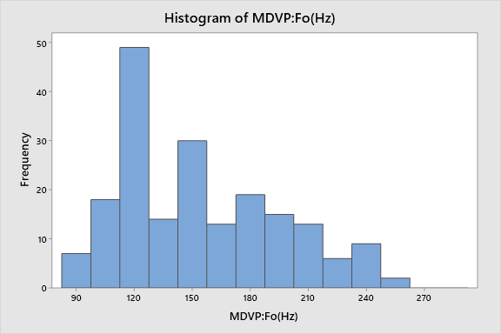

1. **Histogram of attribute MDVP :Fhi(Hz)**

**Shape:** The distribution of MDVP:Fhi(Hz) is unimodal it has one mode at a value of 120 about which the observations are concentrated.

The histogram is right skewed the larger values at right tail is much longer than the left tail.

**Outliers:** Outliers exist.

**Centre:** The centre of distribution approximately at 200.

**Spread:** The data of this attribute range from 120 to 300 .

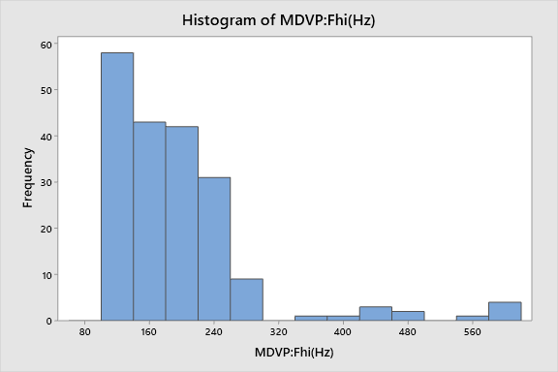

1. **Histogram of attribute MDVP :Flo(Hz)**

**Shape:** The distribution of MDVP:Flo(Hz) is unimodal it has one mode at a value of 105 about which the observations are concentrated.

The histogram is right skewed the larger values at right tail is much longer than the left tail.

**Outliers:** No Outliers exist.

**Centre:** The centre of distribution approximately at 135.

**Spread:** The data of this attribute range from 60 to 240 .

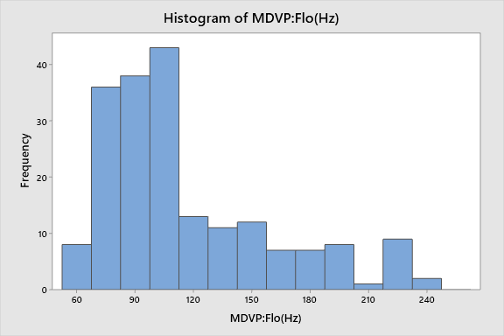

1. **Histogram of attribute MDVP Shimmer:**

**Shape:** The distribution of MDVP Shimmer is unimodal it has one mode at a value of 0.016 about which the observations are concentrated.

The histogram is right skewed the larger values at right tail is much longer than the left tail.

**Outliers:** Potential Outliers exist.

**Centre:** The centre of distribution approximately at 0.048.

**Spread:** The data of this attribute range from 0.08 to 0.096 .

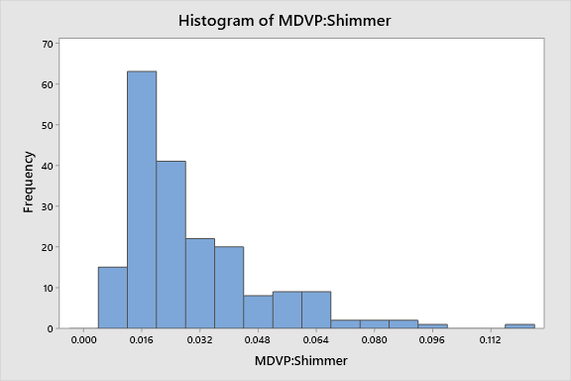

1. **Histogram of attribute HNR:**

**Shape:** The distribution of HNR is unimodal it has one mode at a value of 26 about which the observations are concentrated.

The histogram is left skewed the larger values at left tail is much longer than the right tail.

**Outliers:** No Outliers exist.

**Centre:** The centre of distribution approximately at 22.

**Spread:** The data of this attribute range from 8 to 34 .

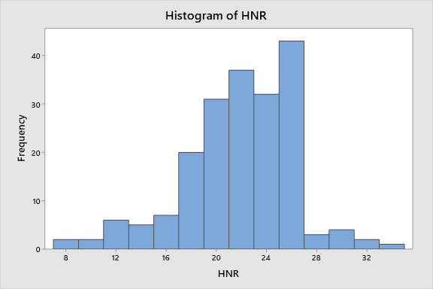

1. **Histogram of attribute RPDE:**

**Shape:** The distribution of RPDE is bimodal it has one mode at a value of 0.44 and other mode at value of 0.48 about which the observations are concentrated.

**Outliers:** No Outliers exist.

**Centre:** The centre of distribution approximately at 0.44.

**Spread:** The data of this attribute range from 0.24 to 0.68 .

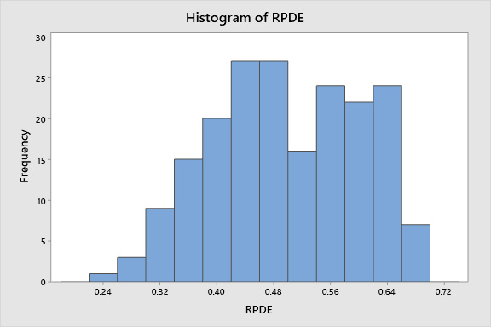

1. **Histogram of attribute DFA:**

**Shape:** The distribution of DFA is bimodal or double peak it has one mode at a 0.66 and 0.68and the other at 0.72 about which the observations are concentrated.

**Outliers:** No potential outliers exist.

**Centre:** The centre of distribution approximately at 0.44.

**Spread:** The data of this attribute range from 0.24 to 0.68.

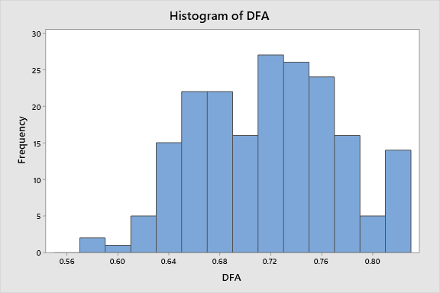

1. **Histogram of attribute Spread 2:**

**Shape:** The distribution of spread 2 is unimodal it has one mode at a value of 0.20 about which the observations are concentrated but comparatively to other attributes its approximately symmetrical

**Outliers:** No potential outliers exist.

**Centre:** The centre of distribution approximately at 0.20.

**Spread:** The data of this attribute range from 0.0 to 0.44.

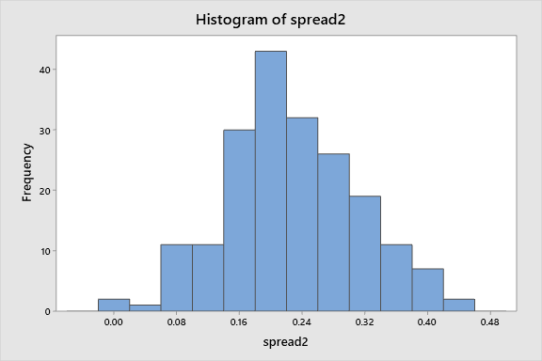

1. **Histogram of attribute D2:**

**Shape:** The distribution of D2 is unimodal it has one mode at a value of 2.4 about which the observations are concentrated but comparatively to other attributes its approximately symmetrical

**Outliers:** No potential outliers exist.

**Centre:** The centre of distribution approximately at 2.4.

**Spread:** The data of this attribute range from 1.4 to 3.6.

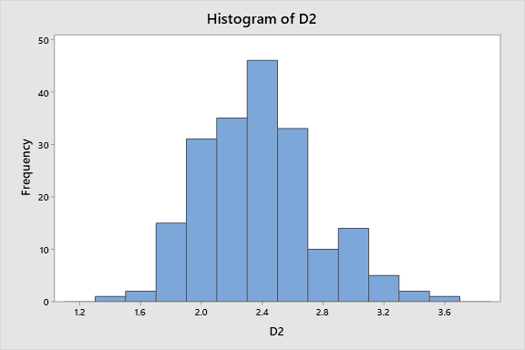

1. **Histogram of attribute Spread 1:**

**Shape:** The distribution of spread 1 is unimodal it has one mode at a value of -5.5 about which the observations are concentrated.

**Outliers:** No potential outliers exist.

**Centre:** The centre of distribution approximately at -5.5.

**Spread:** The data of this attribute range from -8 to -2.5.

